09 May 2016

First IMO Tier III compliant Wärtsilä X72 engine with pre-turbocharger SCR passed shop test

Under IMO’s MARPOL Annex VI, Regulation 13 on oxides of nitrogen, Tier III limits apply in Emission Control Areas (ECAs) for engines in ships with keels laid on or after 1 January 2016. Within less than three months of IMO Tier III coming into force, Winterthur Gas & Diesel (WinGD) and its two-stroke engine manufacturer Hyundai Heavy Industries - Engine & Machinery Division (HHI-EMD), have announced the successful testing and delivery of their first IMO Tier III compliant Wärtsilä X72 diesel engine.

Built at HHI-EMD’s works in Ulsan Korea, the six-cylinder, Wärtsilä X72 diesel engine employs a compact, pre-turbocharger selective catalytic reduction (SCR) system. The system is supplied by HHI-EMD and at a shop test on 23rd March 2016, it demonstrated its ability to reduce the engine’s NOx emissions below the demanding limitations of IMO Tier III for vessels operating in ECAs. Likewise at the shop test, the Wärtsilä X72 engine demonstrated its compliance with the NO_{x} limits of IMO Tier II without exhaust after treatment.

Commenting on its pre-turbocharger SCR system, HHI-EMD notes that locating the SCR catalyst in the hotter exhaust gases before the turbocharger turbine is designed to reliably achieve the temperature level required for the NOx-reducing reaction of the exhaust gases with the urea reducing agent.

In addition to WinGD Korea and HHI-EMD staff, the test was witnessed by representatives of Classification Society ABS Korea, KR, the shipyard Hyundai Samho Heavy Industries, and SeaQuest Marine Project Management. Following the test, the 15’080 kW rated engine (74.7 rpm) was delivered to HSHI(Hyundai Samho Heavy Industry) in Samho-Eup, Yeongam-Gun, South Korea, where it will be installed into a 159’000 DWT Crude Oil Products Tanker.

With IMO Tier III compliance assured, the ship will be permitted to enter North American and Caribbean waters, which is the first ECA to be declared, following the coming into force of IMO Tier III on 1st January 2016. “This demonstration of the ability of our two-stroke engines to comply with IMO Tier III is a clear statement of intent from WinGD and its engine manufacturers to provide ship owners with the engines they need to operate in ECAs”, notes Thomas Werner, Tier III Programme Manager, R&D. “Hence, the ship powered by the Wärtsilä X72 engine will be one of the first capable of complying with IMO Tier III when trading with the USA and Canada.”

Photo:
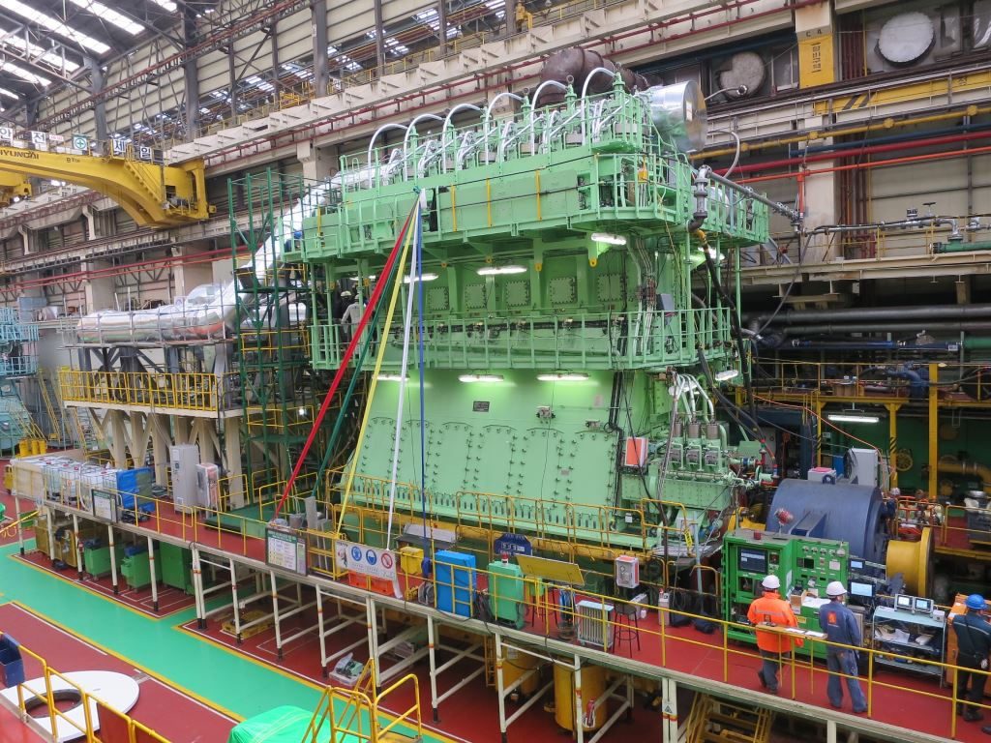
Caption:
The first IMO Tier III compliant Wärtsilä X72 diesel engine with pre-turbocharger SCR passed its shop test on 23rd March 2016.

Media Contacts:
Mr. Thomas Werner
Tier III Programme Manager
Winterthur Gas & Diesel Ltd.
thomas.werner@wingd.com
Tel.: +41 52 262 44 13

Ms. Rong Lin
Marketing Manager
Winterthur Gas & Diesel Ltd.
rong.lin@wingd.com
Tel: +41 52 262 2211

WinGD in brief:
Winterthur Gas & Diesel Ltd. (WinGD) is a leading developer of two-stroke low-speed gas and diesel engines used for propulsion power in merchant shipping. WinGD’s target is to set the industry standard for reliability, efficiency and environmental friendliness. WinGD provides designs, licences and technical support to manufacturers, shipbuilders and ship operators worldwide. The engines are sold under the Wärtsilä brand name and are manufactured under licence in four shipbuilding countries. WinGD has its headquarters in Winterthur, Switzerland where, as one of the earliest exponents of diesel technology, it started the development of large internal combustion engines in 1898 under the “Sulzer” name.

