22 February 2018
Winterthur Gas & Diesel confirms Wärtsilä and CSSC Marine Service as global service providers

To extend their global service offerings, Winterthur Gas & Diesel (WinGD), recently signed agreements with Wärtsilä Services and CSSC Marine Service Co. Ltd. (CMS) as Authorized Global Service Providers.
With these new agreements, valid from January 1st, 2018, both providers can now offer support for all two-stroke engine brands from Winterthur Gas & Diesel, namely WinGD, Wärtsilä and Sulzer. The support includes delivery of spare parts, provision of service engineers, reconditioning and overhaul work on components, training, upgrade solutions and maintenance agreements.

The rights of the Licensed Engine Manufacturers, to provide services to their engines, remain unaffected by these new global service agreements. WinGD’s warranty and customer support will continue while these new agreements allow for normal scheduled and preventative maintenance or long term service agreements to now be provided by Wärtsilä and CMS.

In its promise to support optimum operation of WinGD engines, WinGD has invested in building state-of-the-art training facilities and procedures. Particularly noteworthy are the engine room simulators, which simulate the operation and control of all equipment installed in an engine room. With a focus on the latest generation engines including RT-flex, X-Generation and the new X-DF dual-fuel engines, the simulation facility provides realistic-scenarios of critical situations, like engine shut downs, upcoming alarms or simulated engine malfunctions, which provide valuable experience to trainees for real life situations on-board.

Committed to providing state-of-the-art support, WinGD recently launched WiDE (WinGD Integrated Digital Expert). WiDE, now available for all newly ordered engines, provides a monitoring platform able to record and analyze the performance data of the engine. The system capabilities can be extended on demand to allow continuous, intelligent-diagnostics of the engine and component performance with the goal of scheduling necessary maintenance to avoid unscheduled engine interruptions. Remote access to the collected data, online manuals and troubleshooting guidelines, as well as maintenance preparation support, creates additional value to the crew on-board and to the ship operator.

Dr Rudolf Holtbecker, Director Operations, WinGD, said: “We are very glad to have signed an agreement with these two partners, Wärtsilä Services and CSSC Marine Service.
“It was important to us that Wärtsilä Services remained a key partner. Having been the sole global service provider for many years, they have an extensive global footprint with a full-service solutions portfolio in the lifecycle support for two-stroke engines. CSSC Marine Service, a new company in the two-stroke engines service market, provides additional customer choice and the opportunity to diversify the offered services meeting a larger variety of customer needs.”

ENDS…

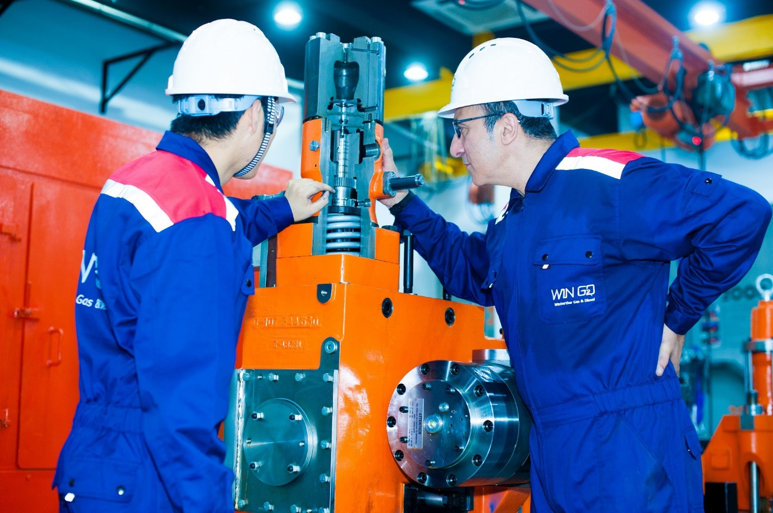

Image caption: WinGD, committed to outstanding service and support.

Media Contacts:
Anna Garcia
Manager Marketing & Communications, Sales and Marketing
E-mail: anna.garcia@wingd.com
Tel.: +41 52 262 85 50

WinGD in brief:
Winterthur Gas & Diesel Ltd. (WinGD) is a leading developer of two-stroke low-speed gas and diesel engines used for propulsion power in merchant shipping. WinGD’s target is to set the industry standard for reliability, efficiency and environmental friendliness. WinGD provides designs, licences and technical support to manufacturers, shipbuilders and ship operators worldwide. The engines are sold under the WinGD brand name and are manufactured under licence in four shipbuilding countries. WinGD has its headquarters in Winterthur, Switzerland, where its activities were founded in 1898.

